1. List the five most common trigrams:
2. Listing seven, as we have a few ties, here are our top five common trigrams:

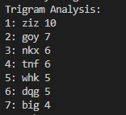

1. Show the difference between the starting indexes of the five most common trigrams:
   1. 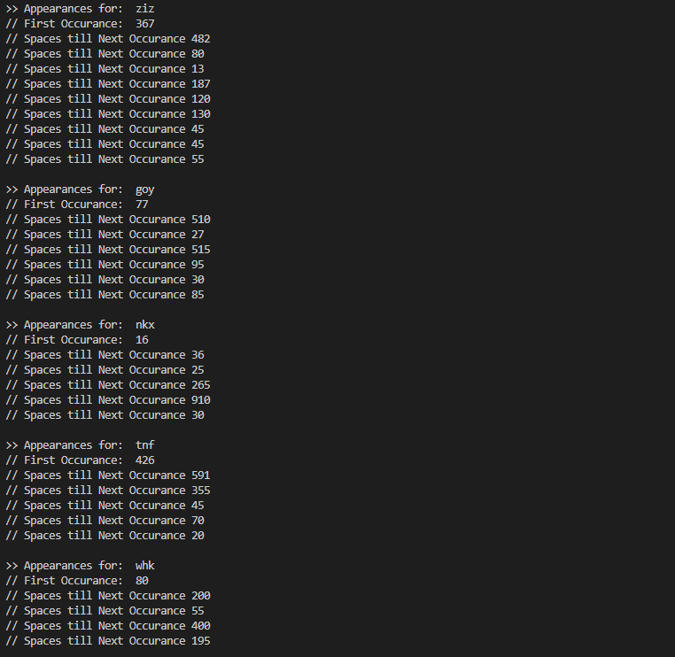Same as before, listing seven – here are the occurrences:

